**Experiment 16**

**Calculator using Java Swing**

**Date of submission:** 18-11-2020

**Aim:** Write a Java program that works as a simple calculator. Arrange Buttons for digits and the + - * / operations properly. Add a text field to display the result. Handle any possible exceptions like divide by zero. Use Java Swing.

**Concepts Used:** Java Swing and event handling

**Algorithm:**

Class Calulator

1. Create JFrame with title Calculator and setDefaultCloseOperation to EXIT_ON_CLOSE
2. Set the layout manger for the JFrame to GridBagLayout
3. Create the JLabel to display the result and to show the numbers entered
4. Add the Jlabel to `display` the number entered and the result
5. Add the Jbuttons with the symbols 1,2,3,4,5,6,7,8,9,0 for the numbers and +,-,*,/ for the operations
6. //Event handling
7. For every numberbutton:
8. if the button is pressed, append the character to the Jlabel
9. Done
10. If +,-,*,/ button pressed
11. case + : add = true,sub=false,mul=false,div=false
12. break
13. case - : add = false,sub=true,mul=false,div=false
14. break
15. case * : add = true,sub=false,mul=true,div=false
16. break
17. case / : add = false,sub=false,mul=false,div=true
18. break
19. endcase
20. a = Float.valueOf(display.getText())
21. endFor
22. If ‘=’ button is pressed
23. flag =false
24. if(add or sub or mul or div of mod)
25. b = Float.valueOf(display.getText())
26. case add: res=a+b
27. break
28. case sub: res = a-b
29. break
30. case mul: res=a*b
31. break
32. case div: if b==0
33. flag=true
34. else
35. res = a/b
36. endif
37. endcase
38. if flag then
39. display.setText(“Divide by 0 error”)
40. else
41. display.setText(res)
42. endif
43. endif

**Result:** The program is successfully compiled and the required output is obtained

**Program code:**

/****************************************

* Calculator implementing the funtions +,-,*,/

* Done By: Rohit Karunakaran

* *************************************/

import java.awt.*;

import java.awt.event.*;

import javax.swing.*;

public class Calculator

{

JFrame jfrm;

JLabel disp;

GridBagConstraints c ;

ActionListener numberButtonPressed;

ActionListener mathButtonPressed;

boolean add;

boolean sub;

boolean mul;

boolean div;

boolean done;

double calc;

public Calculator()

{

jfrm = new JFrame("Calculator");

jfrm.setLayout(new GridBagLayout());

c = new GridBagConstraints();

calc = 0;

add=false;

sub=false;

div=false;

mul=false;

done = true;

jfrm.setSize(270,330);

jfrm.setDefaultCloseOperation(JFrame.EXIT_ON_CLOSE);

disp = new JLabel(String.valueOf(calc));

numberButtonPressed = new ActionListener()

{

public void actionPerformed(ActionEvent ae)

{

JButton callerButton = (JButton)ae.getSource();

String val = callerButton.getText();

String displayText = disp.getText();

if(displayText.equals("ERROR"))

{

disp.setText(val);

}

else

{

if(done ==true){

disp.setText(String.valueOf(Double.parseDouble(val)));

}

else{

double newVal = Double.parseDouble(displayText)*10+Double.parseDouble(val);

disp.setText(String.valueOf(newVal));

}

}

done = false;

}

};

mathButtonPressed = new ActionListener()

{

public void actionPerformed(ActionEvent ae)

{

//done = true;

JButton b = (JButton) ae.getSource();

double result = 0.0;

String val = disp.getText();

if(!done)

{

if(val.equals("ERROR"))

{

disp.setText("0.0");

calc = 0.0;

}

else

{

if(add||sub||div||mul)

{

double operand= Double.parseDouble(val);

if(add)

{

result = calc+operand;

add = false;

}

else if(sub)

{

result = calc-operand;

sub = false;

}

else if(mul)

{

result = calc*operand;

mul = false;

}

else if(div)

{

if(operand!=0.0)

result = calc/operand;

else{

disp.setText("ERROR");

done = true;

return;

}

div = false;

}

calc = result;

disp.setText(String.valueOf(calc));

}

else

{

calc = Double.parseDouble(val);

char op = b.getText().charAt(0);

switch(op)

{

case '+':add=true;break;

case '*':mul=true;break;

case '/':div=true;break;

case '-':sub=true;break;

}

}

}

done = true;

}

}

};

c.anchor = GridBagConstraints.FIRST_LINE_START;

c.fill= GridBagConstraints.VERTICAL;

c.weightx=0.5;

c.gridx=0; c.gridy=0;

c.gridwidth = 3;

c.ipady = 20;

jfrm.add(disp,c);

addButtons();

jfrm.setVisible(true);

}

private void addButtons()

{

c.ipady = 10;

c.gridwidth = 1;

c.fill= GridBagConstraints.HORIZONTAL;

c.anchor = GridBagConstraints.LINE_START;

JButton numbers[] = new JButton[10];

for(int i = 0;i<10;i++)

{

numbers[i] = new JButton(String.valueOf(i));

numbers[i].addActionListener(numberButtonPressed);

if(i!=0)

c.gridx = (i+2)%3;

else

c.gridx = 1;

c.gridy = i%3==0?4-(i/3-1):4-(i/3);

jfrm.add(numbers[i],c);

}

JButton addButton= new JButton("+");

addButton.addActionListener(mathButtonPressed);

JButton subButton= new JButton("-");

subButton.addActionListener(mathButtonPressed);

JButton mulButton= new JButton("x");

mulButton.addActionListener(mathButtonPressed);

JButton divButton= new JButton("/");

divButton.addActionListener(mathButtonPressed);

c.gridx = 3;

c.gridy = 2;

jfrm.add(addButton,c);

c.gridy = 3;

jfrm.add(subButton,c);

c.gridy =4;

jfrm.add(mulButton,c);

c.gridy = 5;

jfrm.add(divButton,c);

JButton equalButton = new JButton("=");

equalButton.addActionListener(new ActionListener()

{

public void actionPerformed(ActionEvent ae)

{

double result = 0.0;

String val = disp.getText();

if(!done)

{

if(val.equals("ERROR"))

{

disp.setText("0.0");

calc = 0.0;

}

else

{

if(add||sub||div||mul)

{

double operand= Double.parseDouble(val);

if(add)

{

result = calc+operand;

add = false;

}

else if(sub)

{

result = calc-operand;

sub = false;

}

else if(mul)

{

result = calc*operand;

mul = false;

}

else if(div)

{

if(operand!=0.0)

result = calc/operand;

else{

disp.setText("ERROR");

done = true;

return;

}

div = false;

}

calc = result;

disp.setText(String.valueOf(calc));

}

else

{

calc = Double.parseDouble(val);

}

}

done = true;

}

}

});

c.gridy=5;

c.gridx =2;

jfrm.add(equalButton,c);

c.gridx = 0;

JButton clearAll = new JButton("AC");

clearAll.addActionListener(new ActionListener()

{

public void actionPerformed(ActionEvent ae)

{

add = mul = div = sub = false;

done = true;

disp.setText("0.0");

}

}

);

jfrm.add(clearAll,c);

}

public static void main(String[] args)

{

SwingUtilities.invokeLater(new Runnable()

{

public void run()

{

new Calculator();

}

});

}

}

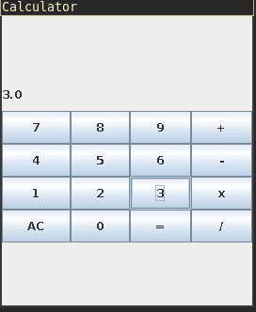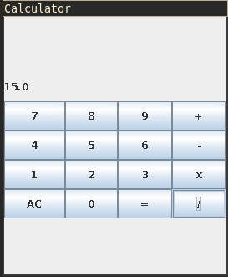

**Sample output**

12+3 =15

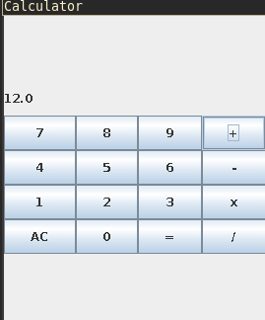

15 / 0 = ERROR

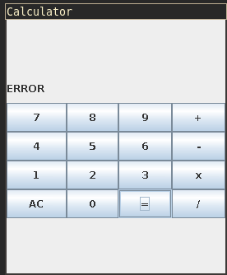

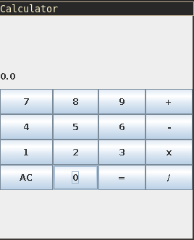

**Experiment 17**

**Traffic Lights using Java Swing**

**Date of submission:** 18-11-2020

**Aim:** Write a Java program that simulates a traffic light. The program lets the user select one of three lights: red, yellow, or green. When a radio button is selected, the light is turned on, and only one light can be on at a time. No light is on when the program starts.

**Concepts Used:** Java Swing, Event handling

**Algorithm:**

1. Create 3 JradioButtons buttons[] with the values “Red” “Yellow” “Green” for the three buttons
2. buttons[0].setBackground(Color..GRAY)
3. buttons[2].setBackground(Color..GRAY)
4. buttons[1].setBackground(Color..GRAY)
5. add the buttons to the Jframe
6. Create a ButtonGroup bg
7. Add the buttons to bg
8. //Event handling
9. button[0] is pressed
10. set button[1] and button[2] to Grey
11. set button[0] tored
12. button[1] is pressed
13. set button[1] to yellow
14. set button[0] and button[2] to Grey
15. button[2] is pressed
16. set button[2] to green
17. set button[0] and button[1] to Grey

**Program Code**

import java.awt.*;

import javax.swing.*;

import java.awt.event.*;

class TrafficLights{

TrafficLights(){

JFrame jfrm = new JFrame();

jfrm.setLayout(new GridLayout(3,1));

jfrm.setDefaultCloseOperation(JFrame.EXIT_ON_CLOSE);

jfrm.setSize(200,500);

JRadioButton signalButtons[] = new JRadioButton[3];

ButtonGroup bg = new ButtonGroup();

signalButtons[0]=new JRadioButton("Red");

signalButtons[0].setBackground(Color.GRAY);;

signalButtons[1]=new JRadioButton("Yellow");

signalButtons[1].setBackground(Color.GRAY);;

signalButtons[2]=new JRadioButton("Green");

signalButtons[2].setBackground(Color.GRAY);;

bg.add(signalButtons[0]);

bg.add(signalButtons[1]);

bg.add(signalButtons[2]);

jfrm.add(signalButtons[0]);

jfrm.add(signalButtons[1]);

jfrm.add(signalButtons[2]);

signalButtons[0].addActionListener(new ActionListener(){

public void actionPerformed(ActionEvent e){

signalButtons[0].setBackground(Color.RED);

signalButtons[1].setBackground(Color.GRAY);;

signalButtons[2].setBackground(Color.GRAY);;

}

});

signalButtons[1].addActionListener(new ActionListener(){

public void actionPerformed(ActionEvent e){

signalButtons[0].setBackground(Color.GRAY);

signalButtons[1].setBackground(Color.YELLOW);;

signalButtons[2].setBackground(Color.GRAY);;

}

});

signalButtons[2].addActionListener(new ActionListener(){

public void actionPerformed(ActionEvent e){

signalButtons[0].setBackground(Color.GRAY);

signalButtons[1].setBackground(Color.GRAY);;

signalButtons[2].setBackground(Color.GREEN);;

}

});

jfrm.setVisible(true);

}

public static void main(String[] args){

new TrafficLights();

}

}

**Sample output**

